# BOM (per robot)

2x [Servo](https://www.digikey.com/en/products/detail/adafruit-industries-llc/169/5154651) ($5.95 each)

1x [3V-5V Booster](https://www.digikey.com/en/products/detail/adafruit-industries-llc/4654/12697636) ($3.95 each)

1x [2-pin JST Connector](https://www.digikey.com/en/products/detail/jst-sales-america-inc/S2B-PH-K-S-LF-SN/926626) (<= $0.17 each)

1x [ItsyBitsy 3V Dev Board](https://www.digikey.com/en/products/detail/adafruit-industries-llc/3675/8031669) ($11.44 each)

1x [3V LiPo Battery](https://hobbyking.com/en_us/turnigy-200mah-1s-20c-lipo-pack.html) ($3.49 each)

1x [Set of Dragon Skin 30](https://shop.smooth-on.com/dragon-skin-30) ($36.89 each) (each robot uses around 100 g total)

2x Washers

1x Spool of Fishing Line (or fishing line in general)  
2x 3-pin board connector (can be used from extra connectors that come with the ItsyBitsy or booster)

Total price (of linked parts): $67.84

* Assuming each set of Dragon Skin 30 comes with 900 g total, using only 100 g would bring the price down to $34.95

# Body Structure Files

* ALL FILES Printed with High Speed PLA profile
* [Prototype Files](https://drive.google.com/file/d/1b_J-L70NpBMhjSTjukNvuKA0TYcu7FGA/view?usp=sharing)
* [Final Soft Body Files](https://drive.google.com/file/d/1pev9rPWN_qg7TgqdF9Gr0Ul88zvJY38Y/view?usp=sharing)

# Electrical Schematic and Board Files

* Milled with one-sided copper sheets, copper side face up in mill
* 1/64” drill bit
* [Electrical Files](https://drive.google.com/file/d/14HYk3L7_f8Piv6ouqpcXZL93k8bdjsIz/view?usp=sharing)

# Software Files

* USB-A to Micro USB cable needed to flash code onto board
* Programmed through Arduino IDE
* [Program Files](https://drive.google.com/file/d/1dbuXq2EUp_y6uo9tRPLNIkV_PR0MaL2D/view?usp=sharing)

# Build Instructions

## Actuators

1. (OPTIONAL) If different shaped actuators are desired:
   1. Open the actuator_mold_construction folder within the body_files folder
   2. Adjust the actuators within easymodactuator_grove* files
   3. Open up the flatgroove* files and rebuild each one
   4. Open up the grooveblock* files and edit the Split features
   5. Under the Resulting Bodies section, for each body double-click on <None> (if there is already a title, double-click the title name instead), New Part, Browse, and enter in whatever name you desire, in the directory you want to save the file to.
   6. Click on the green checkmark to finalize the split; each part of the mold should be autogenerated and appear as separate SLDPRTs
2. Save each mold SLDPRT part as a STL file, and print them using a 3D printer
3. For each mold pair, put a piece of tubing in the cavity formed when pressing the two pieces together
4. Use two screws to screw together the mold parts and tape on the bottom half of the mold to prevent as much material from leaking out as possible
5. Mix together 15 g of EACH part of Dragon Skin 30, and use the vacuum chamber to remove as many air bubbles as possible
6. Pour in the material to the molds, and wait at least 4 hours for the actuators to cure
7. Take the actuators out of the molds
8. Use scissors to cut the exposed tubing, until the tubing is flush against every surface
9. For the surface of the actuator that formed as the “top” of the actuator in the mold, put that surface face down on a table and use an exacto-knife or similar tool to precisely remove excess material
10. Any other stray tags/bits of material may be picked off by hand
11. Feed fishing line through the tubing and put a washer on the non-base end of the line.
12. Secure the fishing line to the non-base end by tying a knot

## Soft Body

1. (OPTIONAL) If a different body shape is desired:
   1. Open the soft_body_construction folder within the body_files folder
   2. Open the chassis.SLDPRT file and adjust as necessary
   3. Open the cassem assembly file and rebuild
2. Open the cblock.SLDPRT file and save as a STL file
3. Print out the STL file using a 3D printer
4. Mix together 20 g of EACH part of Dragon Skin 30 and use the vacuum chamber to remove as many air bubbles as possible
5. Pour the material into the molds, and wait at least 4 hours for the material to cure
6. Take the soft body out of the mold; be careful as some parts are easier to tear than others
7. Use an exacto-knife or other similar tool to remove excess material in undesired places

## Circuitry

1. Locate the turtlebot.brd file within the electrical files
2. Use double-sided tape to secure the one-sided copper sheet to the mill bed
3. Use 1/64” drill bit
4. Print out the board
5. Solder the components to their respective spots
6. Attach the servos to the 3-pin connectors
7. Upload the code onto the dev board
8. Place the PCB into the designated slot on the soft body
9. Place the battery into the designated slot on the soft body
10. Use extra Dragon Skin 30 to pour into the slots, to “glue” the places on the board

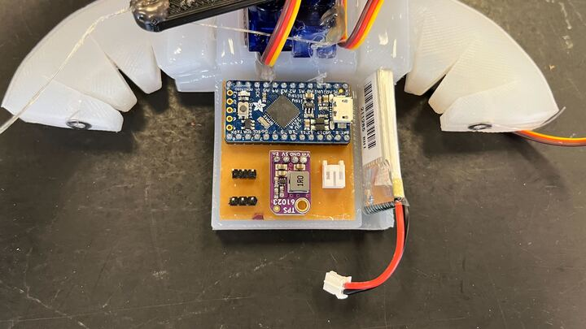

## Last Steps

1. Use extra Dragon Skin 30 to glue the actuators to their designated slots; make sure to have the actuators flush against the slope on the soft body (unless the design was changed)
2. Use extra Dragon Skin 30 to glue the servos in place
3. Attach the servo attachments (print them out first) to the servo heads and secure with hot glue
4. Feed the fishing lines through their respective servo attachments and secure each line with hot glue
5. The robot will begin moving once the battery is connected to the board

# Future Steps

* Add wireless control
* Flip side to put actuators on to see if the robot can “pull” itself instead of push
* Change design so that the sloped area to attach the actuators to is flat, and the actuator has a bend in it
  + Potentially makes gluing the actuator on much easier
* Design better method to attach actuator to soft body
* Further improve actuator design to achieve faster speed
* Find better servos that can handle faster turning speeds
* Adjust battery slot so that it doesn’t block the USB port on the dev board, but can still reach the battery connector
  + Maybe redesign the board if it makes it easier to do so